About the module: Key points for students
Google Docs
You are encouraged to explore the features of the word processor you are using but to get started there here a few useful features.
Getting started
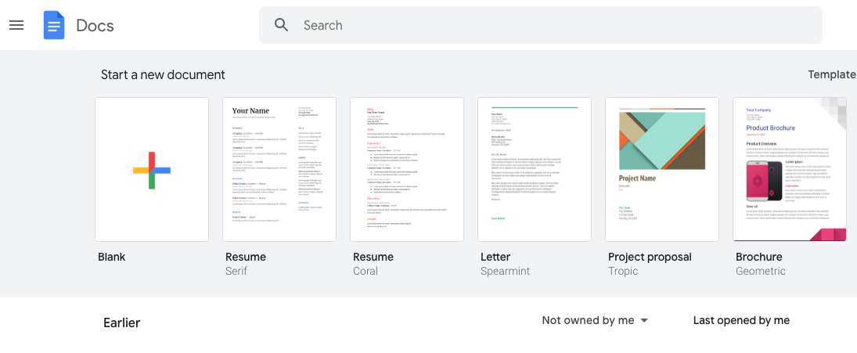
When you open Google docs it presents a choice of templates that you can use as a starting point or you can simply select a blank document.
The ribbon
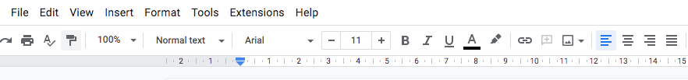

Features to select:
text alignment, left, centre, right or full.
etc
Features to select:
the font and size
set text to Bold, Italics, Underlined and choose text colour.
A range of formatting options such as titles and headings

The insert tab allows you to insert images and drawings.
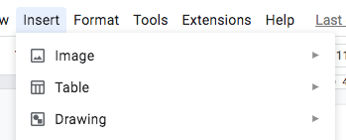
If you select ‘Drawing’ and ‘New’ it opens a new window for you to create a drawing.
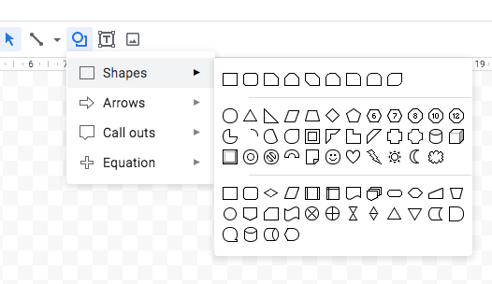
Google Slides
To get started, create a new presentation by choosing ‘Blank’ or one of the themes.
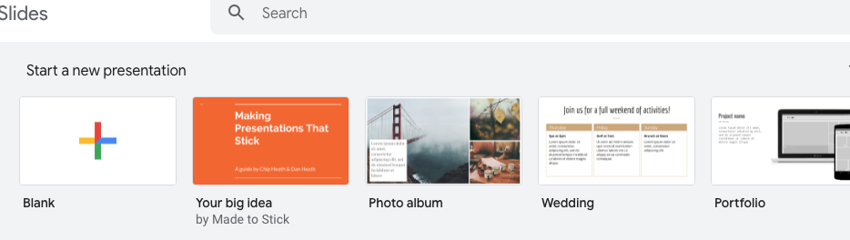
You can start editing by adding text and images to a blank slide.
To add another slide choose the slide tab then select the new slide option to add another blank slide.
There are also options to set up transitions (how a slide transitions to the next one) or to select or change a theme.
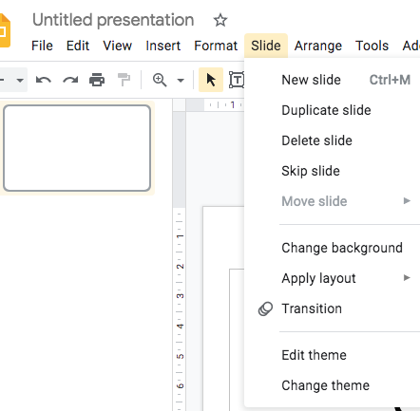

To insert shapes choose ‘Insert’, ‘Shapes’ and select the required item(s).
